PLIS public calendar guide

PLIS public Calendar
The Department of Education’s Professional Learning Information System (PLIS) public calendar is where public users can:
- search and register to attend professional learning events accessible to the public.
- submit an expression of interest (EOI) for an event that is fully booked.
- save their favourite events.

To access the PLIS public calendar and register for an event, you will need a PLIS public user account.

Please note:
- Parent Connect or VacSwim P-Numbers cannot be used to access the public calendar. You must create a new P-Number account specifically for PLIS.
- A PLIS P-Number account can only be created by the individual who will own the account.

The following instructions can be used to register and manage a P-Number account.

Register a public user (P-Number) account
Step 1: Access the PLIS public calendar:
https://plis.education.wa.edu.au/public.aspx
Step 2: Create a public user account.
- Select the Create Account link. This is located towards the upper right-hand side of the screen.
Step 3: Enter your details.  - Enter in your personal information.  - Select the Next button. | 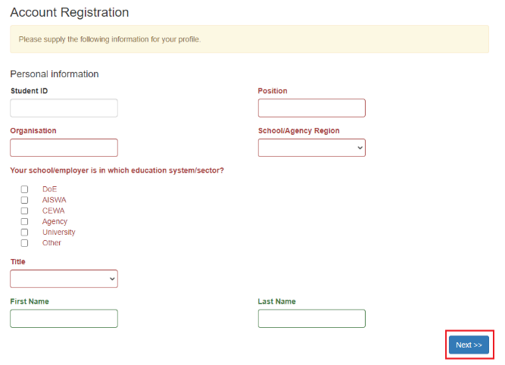  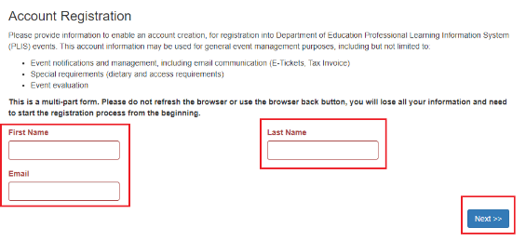
If you already have a PLIS account, you will be prompted to log in. If you have forgotten your P-Number username or password, you can click on the "Forgot your password" link to reset your password. | 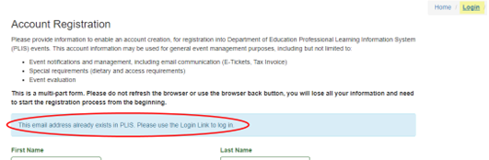  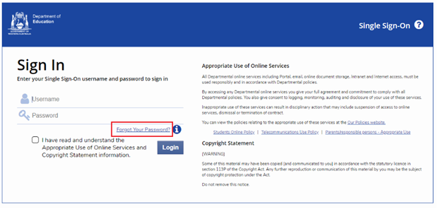
Step 4: Enter your work contact details.  - Enter you work contact details.  - Select the Next button. | 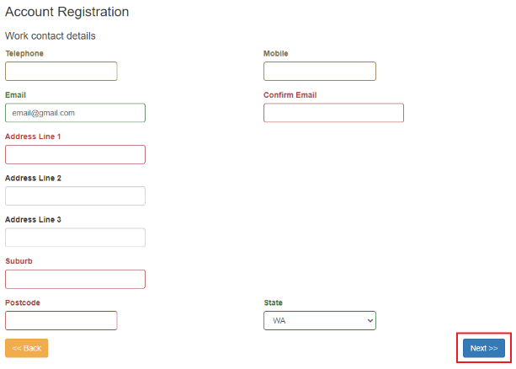
Step 5: Provide your dietary and access requirements.  - Enter your dietary and access requirements.  - Select the Next button. | 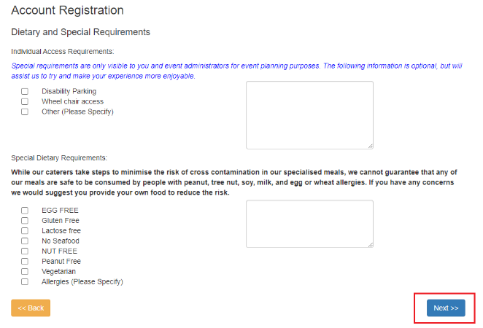
Step 6: Set and confirm a password.  - Enter and confirm a password.  Note: Should you forget your password in the future, a password reset can de done. | 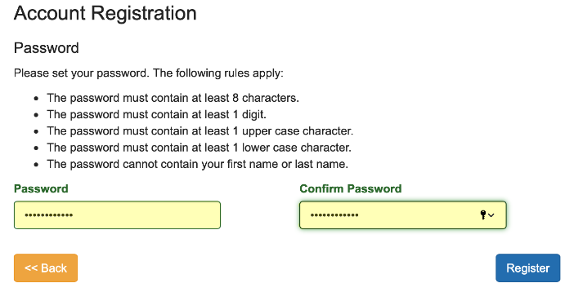
Step 7: Finalise the account registration process.  - Select the Register button.  - You will receive a verification email to your nominated email address.  - Close the browser and navigate to your email. | 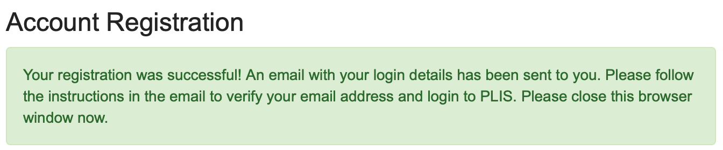
Step 8: Verify your email.  - Open the account verification email.  - Take note of the P-Number that has been issued to you.  - Select the link to verify your email address. | 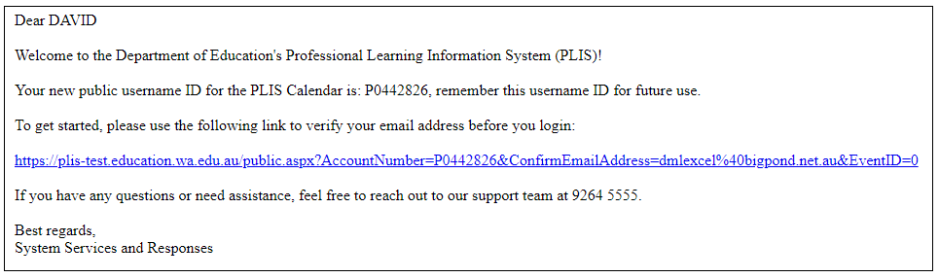
Step 9: Log into the PLIS public calendar
- The PLIS public calendar will automatically launch in a new browser tab, logged into your account.
- The system message ‘Your email address was verified’ will display, you can now search and register for an event will display.

Event Registration

Register for an event in PLIS
Step 1: Open the PLIS public Calendar: | https://plis.education.wa.edu.au/public.aspx
Step 2: Log in  - Select the Login button. The Department’s Single Sign On (SSO) page will appear.  - Enter your P-Number and password.  - Activate the ‘I have read and understand the Appropriate Use of Online Services information.’  - Select the Login button | 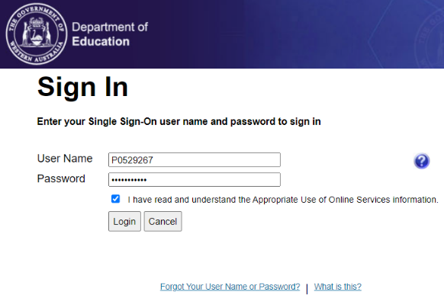
Step 3: Search for the event  - Find an event | 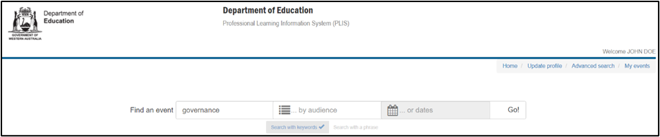
Step 4: Register for an event
- Select the Register button to launch the registration cart – another browser tab should open. If this does not occur, the browser may have a pop-up blocker.
- If you need to provide or update personal information, select the Update Registrant Details or the Update Dietary Req. button
Step 5: Select Sessions  - Select the Select Sessions button to proceed further, or  - If you are registering a colleague on their behalf, select the Add Registrant button and enter your colleague’s P-Number or name. | 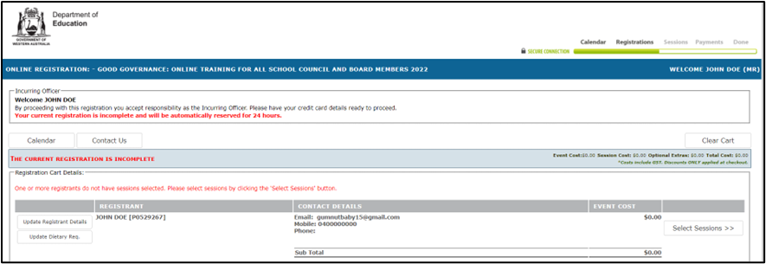
Step 6:
- Select the Next button
Step 7: Confirm the registration details.  - Select the Confirm button to finalise the registration. If there is a registration fee to pay, select the Secure Payment button. | 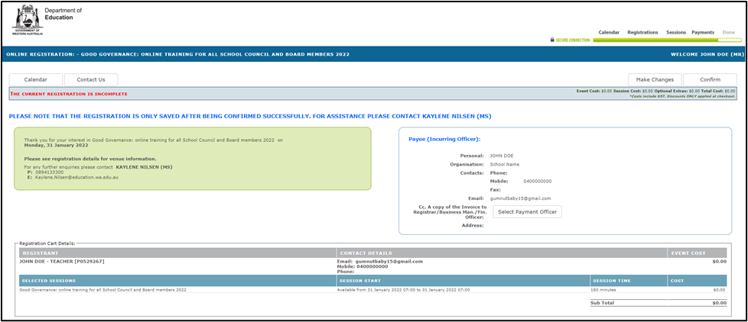
Note: To amend the registration prior to confirming, simply click the Make Changes button.
Step 8: Complete the registration.
- Select the OK button
Note: Once the registration is complete, E-Ticket/s and Tax Invoice/s are emailed to the registrations automatically and an Outlook Calendar appointment is generated.

Password Reset

Reset your password
Step 1: Open the PLIS public Calendar. | https://plis.education.wa.edu.au/public.aspx
Step 2: Start log in.
- Select the Login link
- Select the Forgot Your User Name or Password? link.

Please note: that after three failed login attempts, your account will be locked for security reasons. To request an account unlock, please contact ICT Customer Service at 9264 5555.

Step 3: Provide your email.  - Enter your P-Number or email address in the For Parents and Public Accounts field.  - Select the Next button | 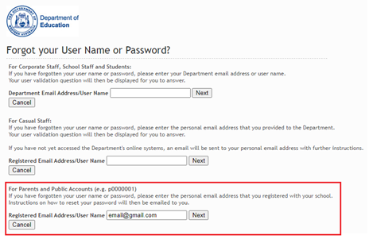
Step 4: Submit a password reset request.
- An email will be sent to you registered email address.
- Close the browser.
Step 5: Activate the reset via email.
- Navigate to your email inbox and locate the email form the Department of Education.
- Select the here link in the email body to reset your password
Step 6: Enter a new password.  - Enter a new password.  - Select the Reset Password button. | 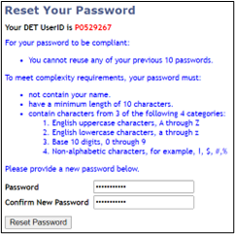
Step 7: Reset Confirmation.  You will receive a confirmation that your password has successfully been reset. Please close this browser and open the PLIS public Calendar | 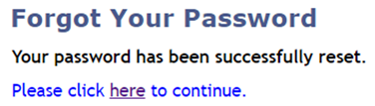  https://plis.education.wa.edu.au/public.aspx

Frequently asked questions
Does submitting an ‘Expression of Interest’ for an event mean that I will be enrolled in the event or receive correspondence regarding future events? No. The Expression of Interest (EOI) does not guarantee a place in the event. You are encouraged to monitor the calendar or contact the event contact to discuss your requirements.

How do I update inaccurate or incomplete work contact details? If your work details are inaccurate or incomplete, you can update the information during event registration using the Update Attendee Details feature. Alternatively, you can contact the event coordinator for assistance.

