MULTI-FACTOR AUTHENTICATION (MFA) HELP CARD

Understand MFA
MFA provides an extra layer of security when accessing Department of Education services from outside of the Department network. The Department has applied MFA as one of a range of initiatives to strengthen our cyber security as an organisation and to keep everyone safe.

The Department’s recommended sign-in method is the Microsoft Authenticator application as it is a much better user experience than other methods.

To Register for MFA via Microsoft Authenticator:

- Visit Microsoft’s My Account portal: HTTPS://aka.ms/mfasetup

- Sign-in with your Department of Education email address.
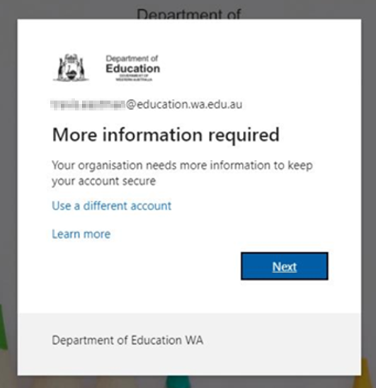
If prompted to select a sign-In method, select Microsoft Authenticator. We do not recommend using SMS or phone call.
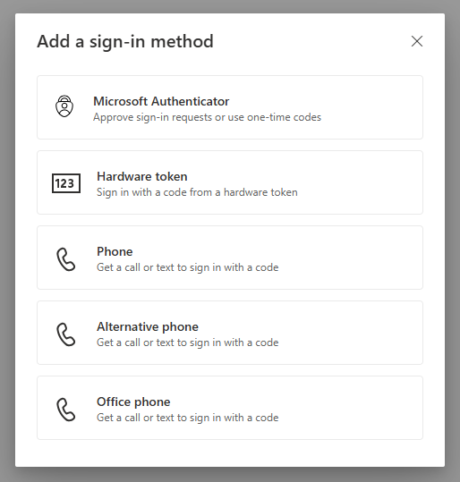

- Follow the instructions on screen to install and configure the Microsoft Authenticator application on your mobile device. You will then be prompted to test the authenticator.
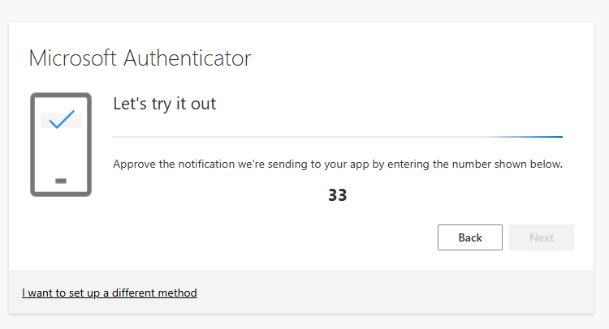
The Microsoft Authenticator application will prompt you to enter the number shown on your browser to authenticate.

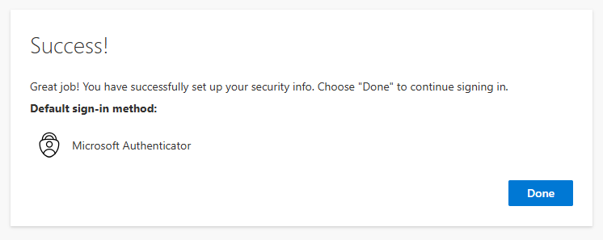

Your MFA is now configured and ready to use.

